Aerodynamics

July 2024

Multi Element Analysis –

3rd Iteration –

Meshing –

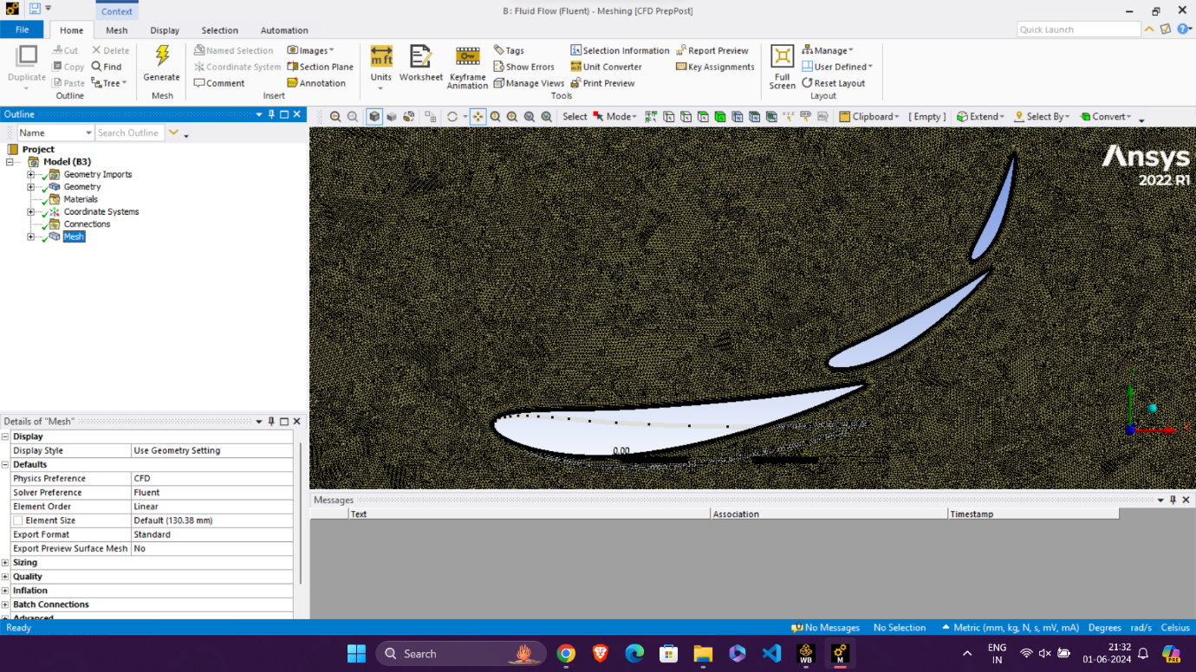

* Face Meshing – 1.2 mm for outer CV
* Face Meshing – 0.5 mm for inner CV
* Inflation – First layer thickness 0.035 mm with growth rate 1.2, 11 layers
* Orthogonal Quality – 0.08 to 1
* All triangles method
* Manual mesh connection

Geometry-

1st element

c = 100 mm

AoA = 8 deg

LE = (0, 0)

2nd element

c = 50 mm

AoA = 32 deg

LE = (91, 15.5)

3rd element

c = 30 mm

AoA = 58 deg

LE = (131, 43.5)

Results-

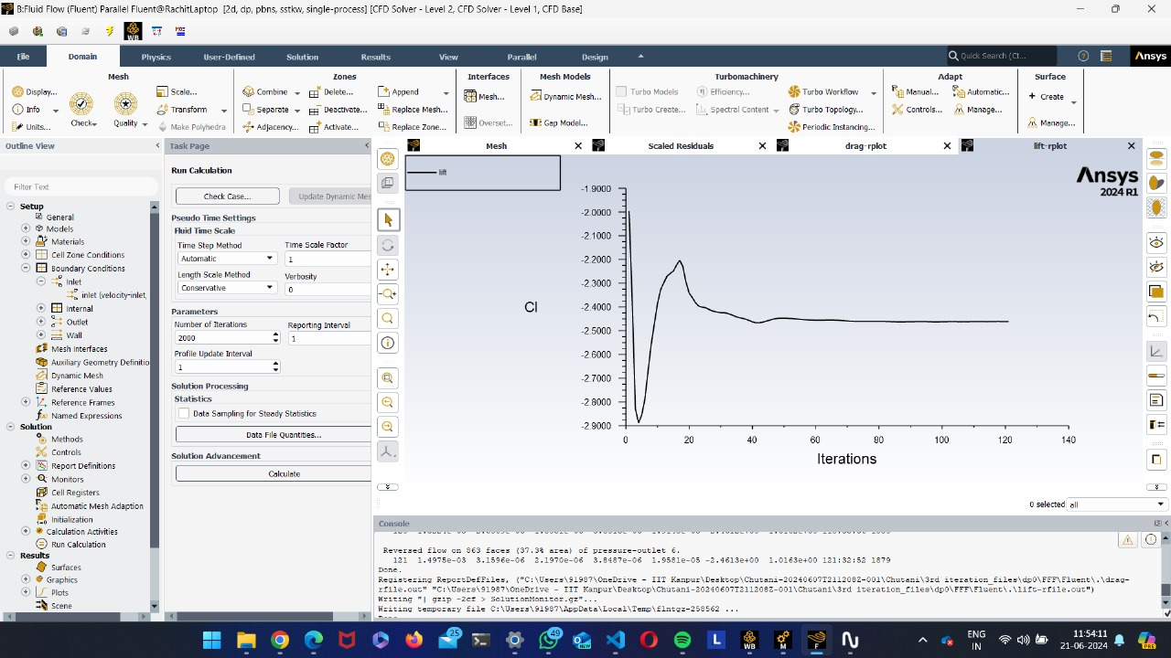

The lift coefficient and drag coefficient plots converged successfully, providing values as –

* Cl = -2.4613
* Cd = 1.0163
* Cl/Cd = 2.4218

2D rear wing, thus achieved the targets set, with Cl/Cd to be above 2.4, though drag can be reduced by reducing the AoA of first element and Cl/Cd can be increased further without compromising much of the downforce.